

**JINNAH UNIVERSITY FOR WOMEN**

2nd assignment of zoology

Topic: national parks of pakistan

Group Member: beenish khan & mehak rafiq

Submitted to: miss mary mehwish

:*Ayubia national park:*

Introduction:

Ayubia National Park (Urdu: ایوبیہ نیشنل پارک‎) (shortened as Ayubia (Urdu: ایوبیہ‎)) is a protected area of 3,312 hectares (8,184 acres) located in Abbottabad District, Khyber Pakhtunkhwa province, northern Pakistan. It was declared a national park in 1984. Ayubia was named after Muhammad Ayub Khan (1958–1969), second President of Pakistan. The area supports temperate coniferous forest and temperate broadleaf and mixed forest ecoregion habitats, with an average elevation of 8,000 feet (2,400 m) above the sea level.

Ayubia National Park is surrounded by seven major villages and four small towns of Thandiani, Nathiagali, Ayubia and Khanspur. The park has been developed as a resort complex from a combination of four mini resorts of Khaira Gali, Changla Gali, Khanspur and Ghora Dhaka in Galyat. Currently, it is manageHistory

Ayubia National Park was established in 1984 in an east corner of Khyber Pakhtunkhwa, province of Pakistan. In 1998 it was expanded form its original size of 1,684 hectares (4,161 acres) or 16.84 km2 (6.50 sq mi) to 3,312 hectares (8,184 acres). Since then it has been managed by the Khyber Pakhtunkhwa Wildlife Department. The purpose of establishing it was to conserve the temperate forests. Originally, the park stood at an area of 857 acres (3.47 km2), but in 1998 it was expanded to cover an area of 1,685 acres (6.82 km2).The total population of Ayubia and surrounding villages as per a 1996 census is18,097 living in 2,311 households.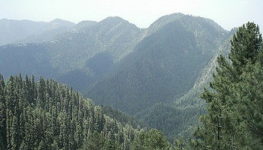

Climate:

Track in Ayubia

The climate of the park is cold in the summers, but harsh in the winters. While it remains only placidly hot in May and June, the cold sets in when the monsoons come to lash in late July and early August. In the winters cold increases in severity gradually until the west winds bring rains, which eventually turn into snow. The park remains snow-capped through the later part of winters.

Rainfall: 1,244 cm

Temperature: 3 °C - 11 °C

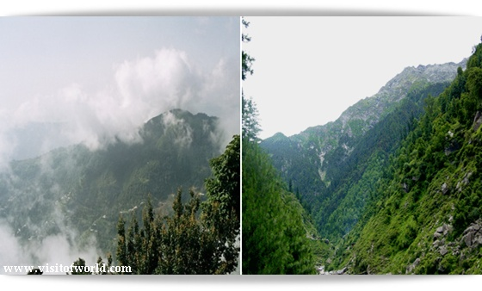

Wildlife:

A panoramic view of Tilla Donga

The park holds 104 species of plants. The main floral species are Cedrus deodara, blue pine, yew, silver fir, horse chestnut and oak. Around 21 plants belonging to 19 families are known for their medicinal properties. Many of these are used in treatment of jaundice, stomach ulcers, snake bites, internal infections, diabetes, psoriasis and more. Some plants are said to have anti-caricogenic effect as well. Also, some are used as biological insecticides and pesticides, mostly due to their insect-repellant nature. The World Wide Fund for Nature has launched an ethno-botanical initiative here "to demonstrate the sustainable use of plant resources as a means for protecting biodiversity."

The park harbors up to 203 species of birds. Many species of birds, including the golden eagle, the vulture, Eurasian sparrowhawk and the hill pigeon among others can be found here. It is also home to some of the rarer Himalayan pheasant species like the kalij and koklass pheasants. Ayubia National Park supports 31 species of mammals. Animals such as the Asiatic leopard, hill fox and flying squirrel can be found here.

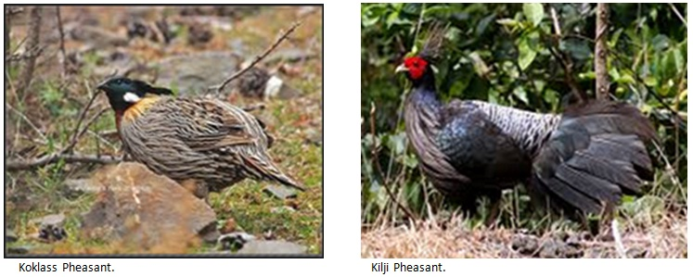

Management:

The park has been managed by Khyber Pakhtunkhwa Wildlife Department under the 1975 Khyber Pakhtunkhwa Wildlife Act. The headquarters of the park is at Dunga Gali, which is situated at a distance of 34 km from Abbottabad and 30 km from Murree.National Park started from the behind of Ayubia Chair lift. In National Park walk track near about distance 4 km from Ayubia Chair lift to Dong Gali. There are many beautiful places. It is also sitting arrange on the way when you start from walk Ayubia to Donga Gali in the National Park.

Darwaza Ayubia

Darwaza is a village near Ayubia, situated in the Abbottabad district Union Council Palak, Khyber Pakhtunkhwa, Pakistan. The population of Darwaza is about 5000.

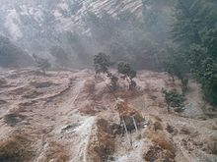

Chamb is a small Mohalla of Village Darwaza which is at a distance of about 2 km from Kuza Gali. Chamb is linked to main Ayubia/[Nathia Gali Road through a link Road from Khaira Gali, Jandala to Darwaza. The population of Chamb is around 1000 and the main places of Chamb are Butti, Kohri, Purana Chamb, Upper Chamb and Lower Chamb. Chamb is considered to be one of the most literate area of Village Darwaza although there is no school in Chamb. About 60 percent of the population of Chamb is associated with hotel industry. Chamb consists of two main Clans—Totyals and Terwals. Totyals are about 80 percent of the population of Chamb.

Ander Kote is a village near Riyali with a population of about 1000 people. There is a primary school in Ander Kote for boys. Main Clans of Ander Kote are Nayyal and Hajyals.

Bagla is a mohalla near Jandala with deobandi Sunni Majority population. Bagla is situated very close to Madrassa Wali Dukhtaran-e-Islam Academy Panyali. Bagla is on the way of Khaira Gali Darwaza Road.

Bantan is considered to be the main hub or in other words, the capital of Darwaza. The population of Bantan is less than 1000 people but this mohalla is very much known for sectarian and political fighting and tussles.

*Margalla Hills National Park*

Introduction:

Margalla Hills National Park (MHNP) is a national park located on the north of the Islamabad City, within the Islamabad Capital Territory in Pakistan. The park includes the Margalla Hills which form's the foothills of the Himalayas, along with Shakarparian Park and Rawal Lake.

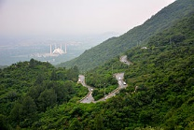

Established in 1980, MHNP cover's approximately 17,386 hectares (67.13 sq mi), Tilla Charouni with a height of 1,604m is tallest peak in the park. MHNP is a popular tourist destination, with Daman-e-Koh and Pir Sohawa serve as popular hill stations, while Shakarparian Cultutal Complex and Lake View Park are popular picnic spots.

The park is rich in biodiversity especially rich in Sino-himalayan fauna, most notably gray goral, barking deer and the Leopard. Combined MHNP is home to around 600 plant species, 250 bird varieties, 38 mammals and 13 species of reptiles. PTDC is currently constructing a chairlift project in the park

Location:

Instituted in 1980, the Margalla Hills National Park comprises the [Margalla Hills](https://en.wikipedia.org/wiki/Margalla_Hills" \o "Margalla Hills) (12605 hectares) the [Rawal Lake](https://en.wikipedia.org/wiki/Rawal_Lake" \o "Rawal Lake), and [Shakarparian](https://en.wikipedia.org/wiki/Shakarparian" \o "Shakarparian) Sports and Cultural complex. Located in Islamabad, the capital of Pakistan. The hill range nestles between an elevation of 685 meters at the western end and 1,604 meters on its east.

Paleontology:

[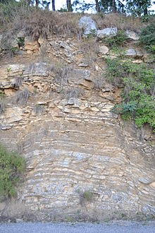](https://en.wikipedia.org/wiki/File:Purana_Margalla.JPG)

Rock layers below Tilla Charouni the highest peak in [Margalla Hills](https://en.wikipedia.org/wiki/Margalla_Hills" \o "Margalla Hills)

Millions of years ago, these mountain peaks didn’t exist. The Asian continent was mostly intact, but Indian subcontent was an island floating off the coast of Australia. Around 220 million years ago, around the time that Pangea was breaking apart, subconetent started to move northwards. It travelled some 6,000 kilometres before it finally collided with Asia around 40 to 50 million years ago. Then, part of the Indian landmass began to go beneath the Asian one, moving the Asian landmass up, which resulted in the rise of the Himalayas. It is thought that India’s coastline was denser and more firmly attached to the seabed, which is why Asia’s softer soil was pushed up rather than the other way around.[How the Himalayas Were Formed](http://www.todayifoundout.com/index.php/2013/12/himalayas-formed/) The rock formations are 40 million years old, and fossils of marine life abound, it is a clear indication that before the content collision around 40 to 50 Million years ago, these hills were the seabed of the ancient ocean. Fossils of seashells, plants, petrified wood and early sea life [Yorgia](https://en.wikipedia.org/wiki/Yorgia" \o "Yorgia) waggoneri are abound.

These hills are the starting point of the Himalayas. The Himalayas, which stretch some 2,900 kilometres between Pakistan, China, and Nepal, is the world’s tallest mountain range.

Flora and fauna:

The vegetation of the southern slopes is short stuttered, comprising deciduous and evergreen trees with diverse shrub growth. In the north, stand pines and groves of oak. The fauna is mainly Indo Himalayan, with some overlapping of[Palearctic](https://en.wikipedia.org/wiki/Palearctic_ecozone) species. The birds found here are residents as well as winter migrants from higher altitudes of the north, spring and summer visitor for breeding, and short day transit species arrive in spring.

Margalla hills have beautiful torrents gushing down in the [monsoon](https://en.wikipedia.org/wiki/Monsoon). Natural springs are also present. Margalla has a variety of mammals, they include the [Indian leopard](https://en.wikipedia.org/wiki/Indian_leopard), [gray goral](https://en.wikipedia.org/wiki/Gray_goral), [barking deer](https://en.wikipedia.org/wiki/Barking_deer), [wild boar](https://en.wikipedia.org/wiki/Wild_boar), [golden jackal](https://en.wikipedia.org/wiki/Golden_jackal), [red fox](https://en.wikipedia.org/wiki/Red_fox) and the [porcupine](https://en.wikipedia.org/wiki/Old_World_porcupine" \o "Old World porcupine)among others.

It is also home to a large number of birds such as larks, paradise flycatcher, black partridge, shrikes pheasants, spotted doves, Egyptian vultures, falcons, hawks and eagles.

Reptiles such as the Russell's viper, Indian cobra and saw-scaled viper are found here.

Conservation campaigns:

Himalayan Wildlife Foundation is running a project on a sustainable management strategy for the Margalla Hills National Park.

Margalla Hills Society established in 1989 is a registered non-governmental organization with its Head Office in Islamabad, Pakistan. It is managed by an elected executive council. Its main objective is to preserve the natural environment of Margalla Hills National Park and prevent shrinkage of the green areas; to promote public interest in conservation, development and management of forests, wildlife and other natural resources of Margalla hills National Park and to disseminate information about the Marghalla hills National park including its history, geography, flora, fauna culture and its benefits to the citizens of Islamabad.

*Hingol National Park*

Introduction:

Hingol National Park or Hungol National Park (Urdu: ہنگول ) covers an area of 1,650 square kilometres (640 sq mi) and is the largest National Park in Pakistan. It was established in 1988.Hingol is the largest of National Parks of Pakistan and lies on the Makran coast in Balochistan.There are worship places of GANESH DEVA,MATA KALI,GURU GORAKH NATH DOONI,BRAHAM KUNDH,TIR KUNDH,MAHA KALI KUNDA,GURU NANAK KHARAO,RAM JAROKHA BETHAK,ANEEL KUNDH ON CHORASI MOUNTAIN and on the way CHANDRA GOOP , KHARI RIVER and AGHORI PUJA.

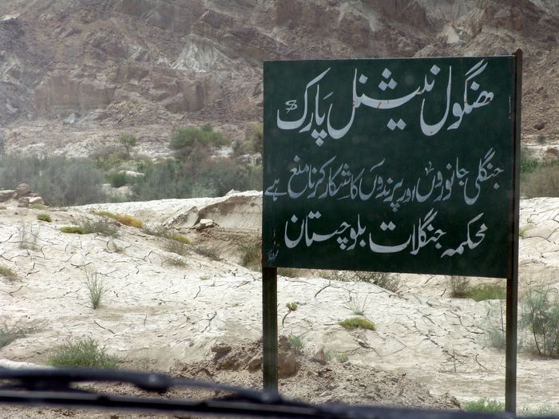

Geography:

Hingol National Park is located along the [Makran](https://en.wikipedia.org/wiki/Makran" \o "Makran) coast in southwestern [Balochistan Province](https://en.wikipedia.org/wiki/Balochistan_(Pakistan)" \o "Balochistan (Pakistan)), southwestern Pakistan. It lies within sections of [Lasbela District](https://en.wikipedia.org/wiki/Lasbela_District" \o "Lasbela District), [Gwadar District](https://en.wikipedia.org/wiki/Gwadar_District), and [Awaran District](https://en.wikipedia.org/wiki/Awaran_District" \o "Awaran District). The [Gulf of Oman](https://en.wikipedia.org/wiki/Gulf_of_Oman) of the[Arabian Sea](https://en.wikipedia.org/wiki/Arabian_Sea) are to the south. The provincial capital of [Karachi](https://en.wikipedia.org/wiki/Karachi) is approximately 190 kilometres (120 mi) to the southeast on the coast

Flora:

Hingol National Park contains a variety of topographical features and [habitats](https://en.wikipedia.org/wiki/Habitat), varying from arid subtropical forest in the north to arid montane in the west. Large areas of the park are covered with drift sand and can be classified as coastal semi desert. The park includes the estuary of the [Hungol River](https://en.wikipedia.org/wiki/Hungol_River" \o "Hungol River) which supports a significant diversity of bird and fish species.

Some 250 plant species were recorded in the initial surveys including 7 yet undescribed species. Many more species are yet to be collected.

Fauna:

Hingol National Park is known to support at least 35 species of mammals, 65 species of amphibians and reptiles and 185 species of birds. The park forms an excellent habitat to wild Sindh ibex, Baluchistan urial and chinkara gazelle. Ibex is found in all steep mountain ranges and numerous in the Hinglaj and Rodani Kacho Mountain areas. Total population is estimated over 3000.

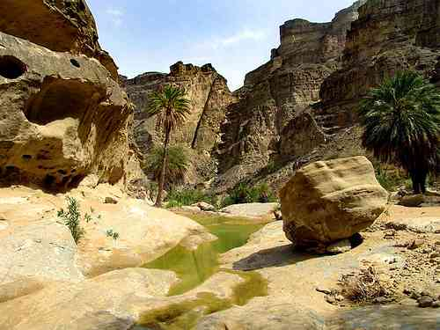

Conservation:

According to independent reports 20 staff members, 18 game watchers and 2 deputy rangers, are currently responsible for the management of the park. They are under the guidance of the park manager, who reports to the conservator and the Secretary of Wildlife, Forest, Livestock, Environment and Tourism.

*Saiful Muluk National Park*

Introduction:

Saiful Muluk National Park is located in the Naran Valley in Mansehra District of Khyber-Pakhtunkhwa, in northern Pakistan. The park was created in 2003. The scenic Saif ul Maluk Lake is in the park.

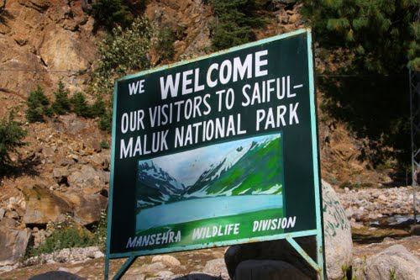

Longitude and latitude:

The Latitude of Saiful Maluk National Park is 34.8581. The Longitude of Saiful Maluk National Park is 73.6889. The Latitude and Longitude of Saiful Maluk National Park is 34.8581 and 73.6889 respectively. 34.8581 Latitude and 73.6889 Longitude can be mapped to closest address of Saiful Maluk National Park, Saiful Muluk Road, Pakistan.

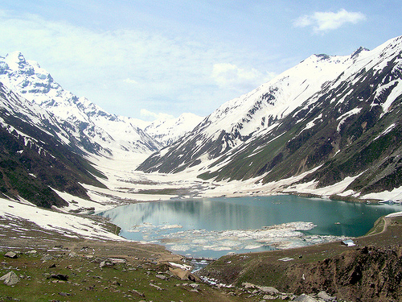

Saiful Maluk National Park is located in sub-locality, locality, District, Khyber Pakhtunkhwa State of Pakistan Country.

Flora and fauna:

The flora includes the trees, shrubs, perennials, and herbs of the [Himalayan](https://en.wikipedia.org/wiki/Himalaya) [Western Himalayan subalpine conifer forests](https://en.wikipedia.org/wiki/Western_Himalayan_subalpine_conifer_forests) and higher elevation [Western Himalayan alpine shrub and meadows](https://en.wikipedia.org/wiki/Western_Himalayan_alpine_shrub_and_meadows) [ecoregions](https://en.wikipedia.org/wiki/Ecoregions).

Some of the park's fauna includes the [snow leopard](https://en.wikipedia.org/wiki/Snow_leopard), [asiatic black bear](https://en.wikipedia.org/wiki/Asiatic_black_bear" \o "Asiatic black bear), [marmot](https://en.wikipedia.org/wiki/Marmot), [weasel](https://en.wikipedia.org/wiki/Weasel), [eurasian lynx](https://en.wikipedia.org/wiki/Eurasian_lynx), [indian leopard](https://en.wikipedia.org/wiki/Indian_leopard" \o "Indian leopard), [Himalayan snowcock](https://en.wikipedia.org/wiki/Himalayan_snowcock), and the [snow partridge](https://en.wikipedia.org/wiki/Snow_partridge). The park's lakes and [wetlands](https://en.wikipedia.org/wiki/Wetland) [habitats](https://en.wikipedia.org/wiki/Habitat) are of significant ecological importance for resident fauna and [migratory](https://en.wikipedia.org/wiki/Bird_migration) [waterfowl](https://en.wikipedia.org/wiki/Waterfowl).

Region:

[Lulusar-Dudipatsar National Park](https://en.wikipedia.org/wiki/Lulusar-Dudipatsar_National_Park), with [Lulusar Lake](https://en.wikipedia.org/wiki/Lulusar" \o "Lulusar) and [Dudipatsar Lake](https://en.wikipedia.org/wiki/Dudipatsar), is adjacent to Saiful Muluk National Park in the Kaghan Valley—[Naran Valley](https://en.wikipedia.org/wiki/Naran_Valley" \o "Naran Valley) region. Together the parks protect 88,000 hectares (220,000 acres).

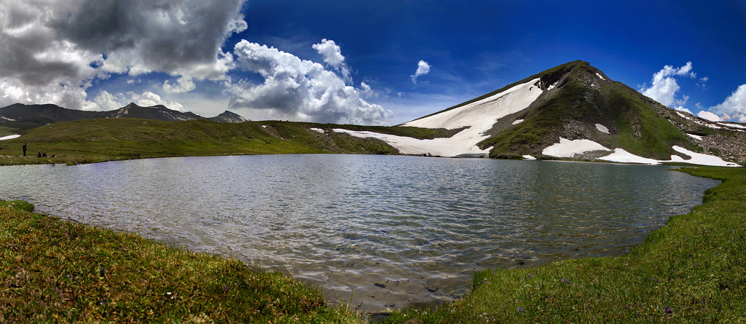

About :

A fairy tale called Saiful Muluk, written by the famous sufi poet Mian Muhammad Bakhsh, is associated with the lake. It is the story of prince of Persia who fell in love with a fairy princess at the lake. The impact of the lake beauty is of such extent that people believe that fairies come down to lake in full moon.

A poet and writer from Balakot, Ahmad Hussain Mujahid, has written the story of Saif ul Malook. The first edition of the book Saif ul Malook was published in 1999.

Mansehra District has had a flourishing tourism industry in the past due to its many mountain ranges and the Saiful Muluk Lake, however since the 2005 earthquake the region has seen a decrease in tourists. This lake is about ten thousand feet above the ground level of Naran, this beautiful lake reflects many colors in minutes. Lately there has been an interest in building hotels in the area.

[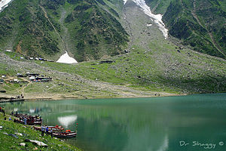](https://en.wikipedia.org/wiki/File:Saif_ul_Maluk_Lake_2.jpg)